GY-80 overview

# Abstract:

This document will hold information relevant to the different sensors on the GY-80.

# Contents:

The GY-80 (overview seen to the right) hold a multitude of chips.

Gy-80 overview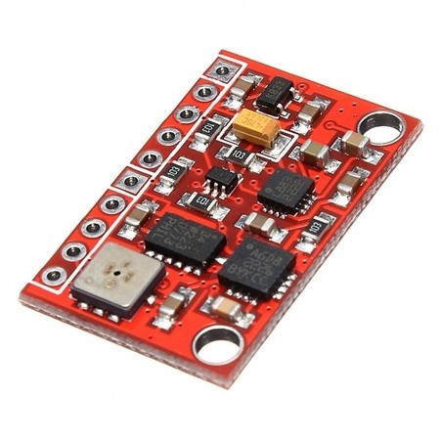

For our project the following 3 are applicable:

3-axis Gyroscope (L3G4200D)

3-axis Accelerometer (ADXL345)

3-Axis Magnetoresistive Sensor (HMC5883L )

The GY-80 board also includes a third sensor:

Barometric pressure and temperature sensor (BMP085 )

However this last one is currently not used by this project.

It is important to take this last sensor into account though;

All the sensors have their own individual I2C address and this 4th sensor will use up one address and this needs to be taken into account when designing the i2c converters.

# I2C addresses

The following addresses are the default addresses:

Magnetometer 0x1E

Accelerometer 0x53

Gyroscope 0x69

Barometer+temperature 0x77

In the design history file there will be a document specifying which resistor configuration on our custom breakout board will lead to which address for which sensor.

# Modes:

### Bypass mode

In this mode it will write the last data into the buffer, if new data is available it will overwrite the old data.

This will cause the rest of the buffer to be empty.

### FIFO mode

In fifo mode the sensor will store data into its buffer, it will hold 32 sets of data.

It will put the oldest values in the registers that are read out.

Once full it will stop datacollection.

### Stream mode

In stream mode data is inserted into the buffer just as in fifo mode, however when the buffer is full it will start overriding the last piece of data.

There are 2 more modes which rely on a so caled trigger events, since we are not interested in those events we will not discuss these further.

The sensor is default in Bypass mode, which means that when we measure we are taking the last known measurement. This is desirable for our case and does not need to change.

# Different settings

All the sensors are set by default to bypass mode (all sensors have a mode that is similar to bypass mode). This means that the sensors measure an individual point in time.

They do not measure over a certain time period and the data given is raw data and needs to be calibrated depending on the settings used.